**FSD SMC(StockMarketCharting) Operation Guide**

**Part 1:** **User Registion**

**Step1 : Register user :**

**first click send email button and get verify code.**

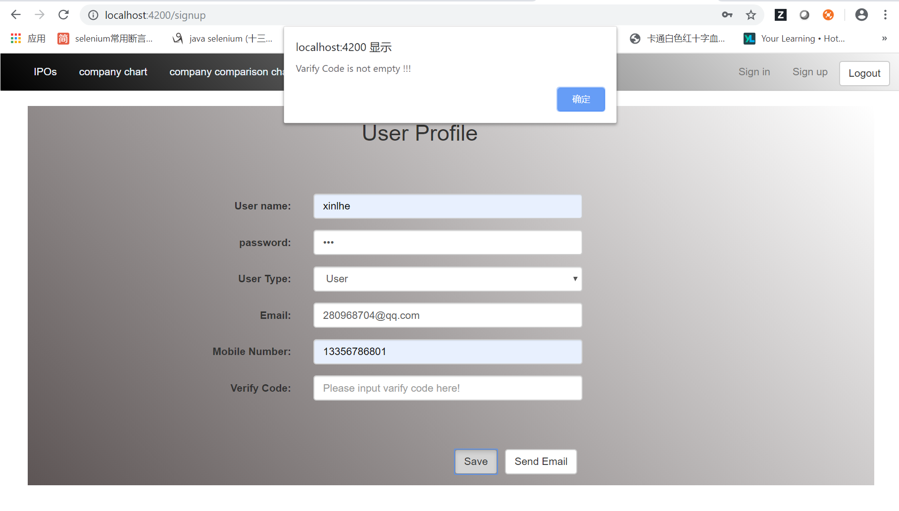

**This page is go to mailbox and get the verify code.**

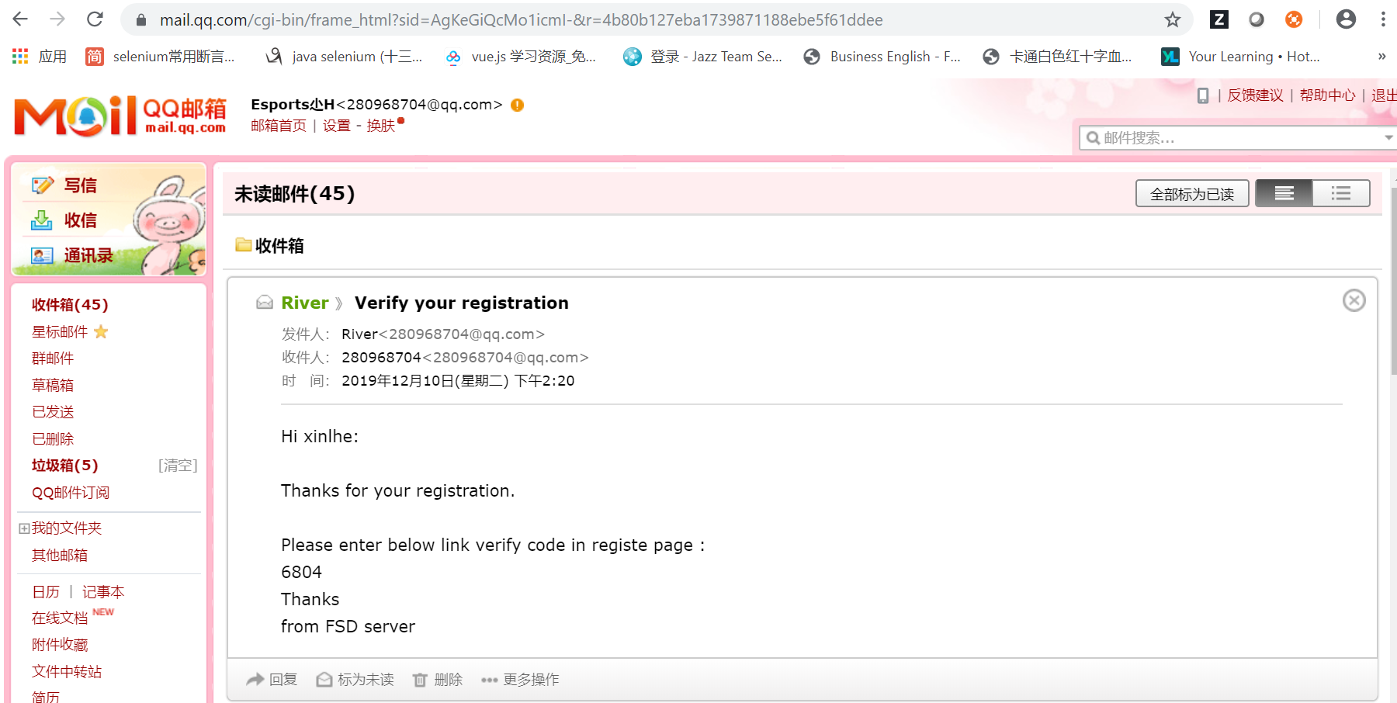

**Input the verify code and click save button.**

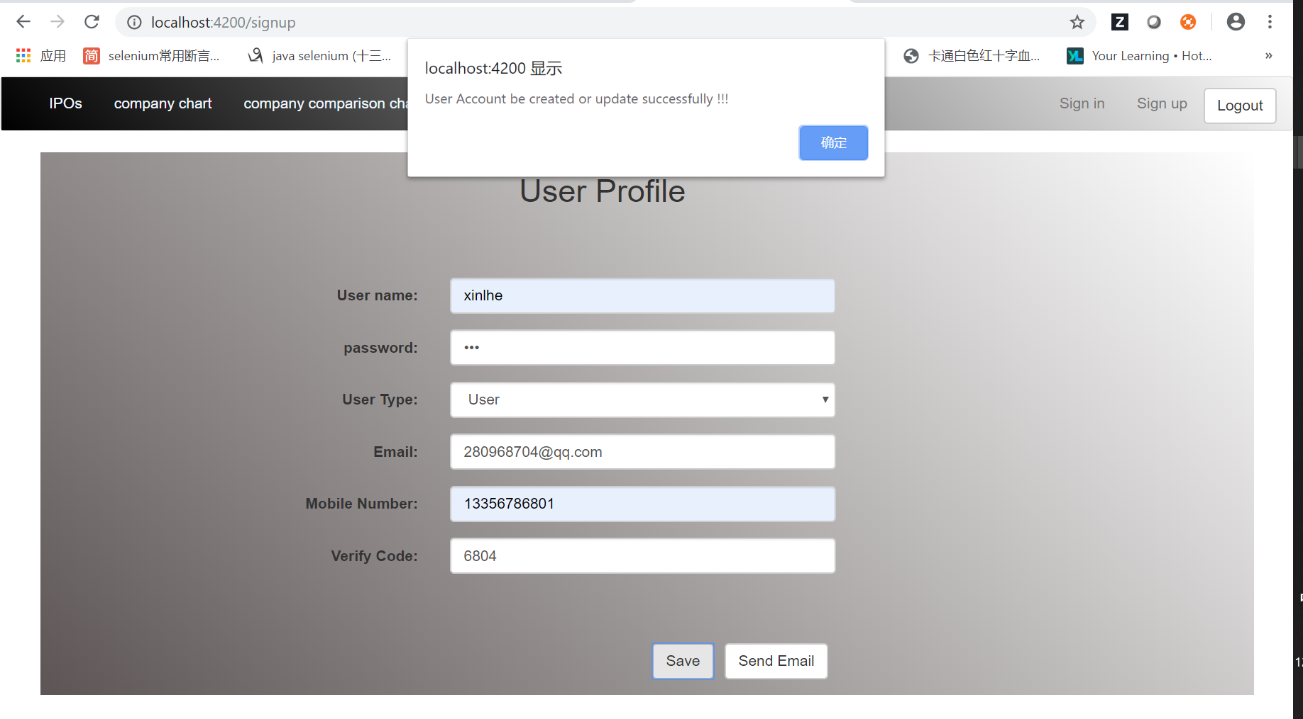

**Step2 : User Signin**

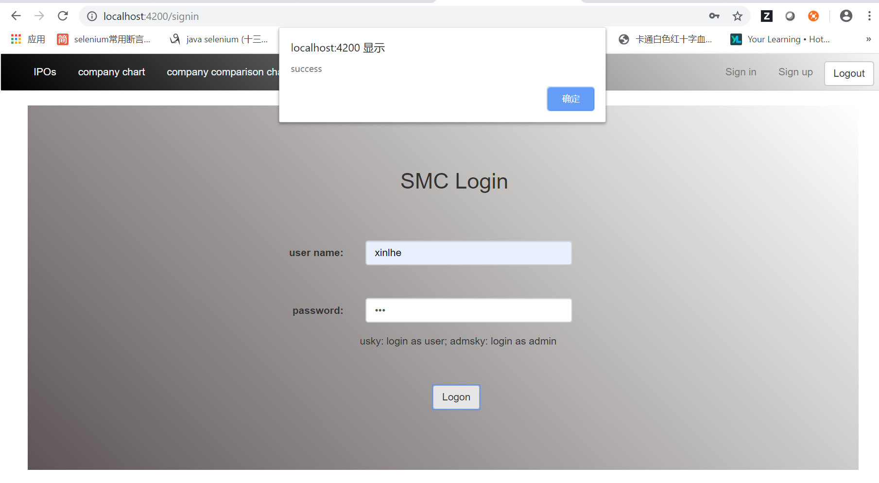

**User logon success, the welcome page is company chart page for normal user.**

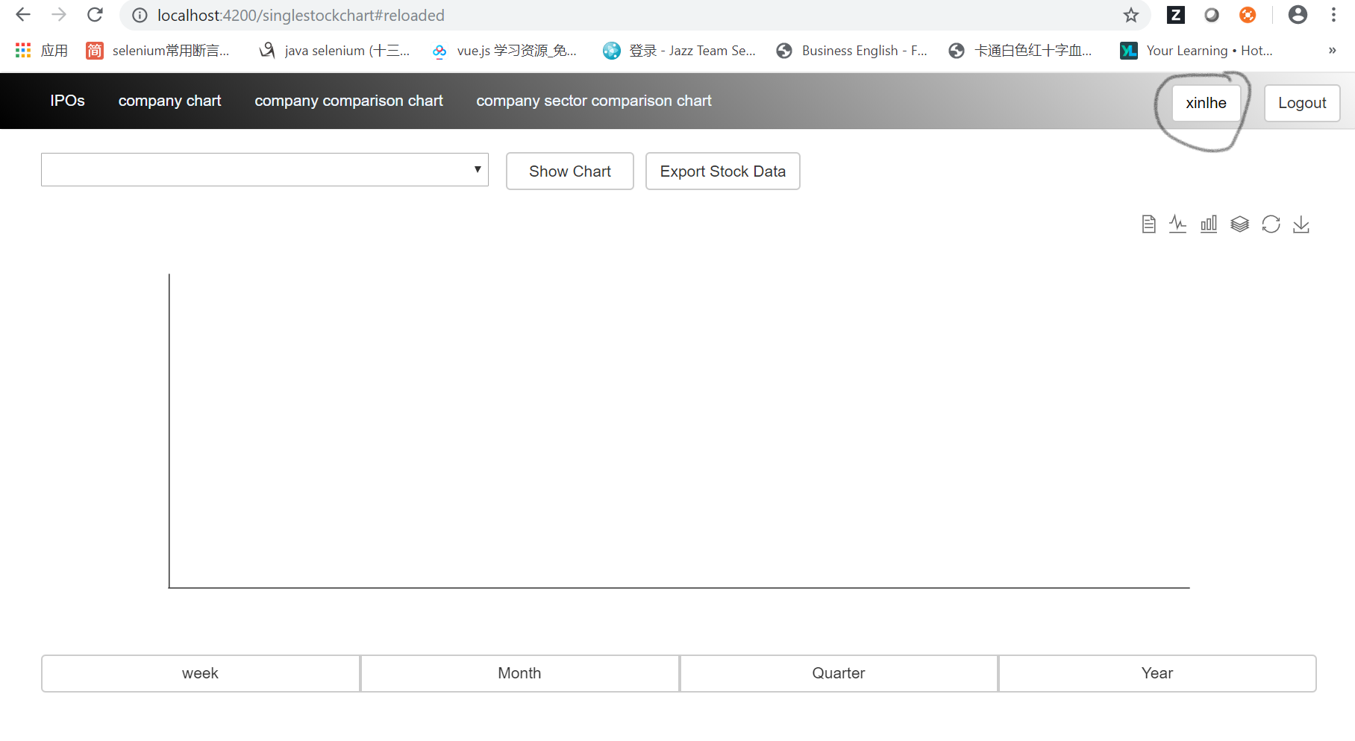

**Admin signin**

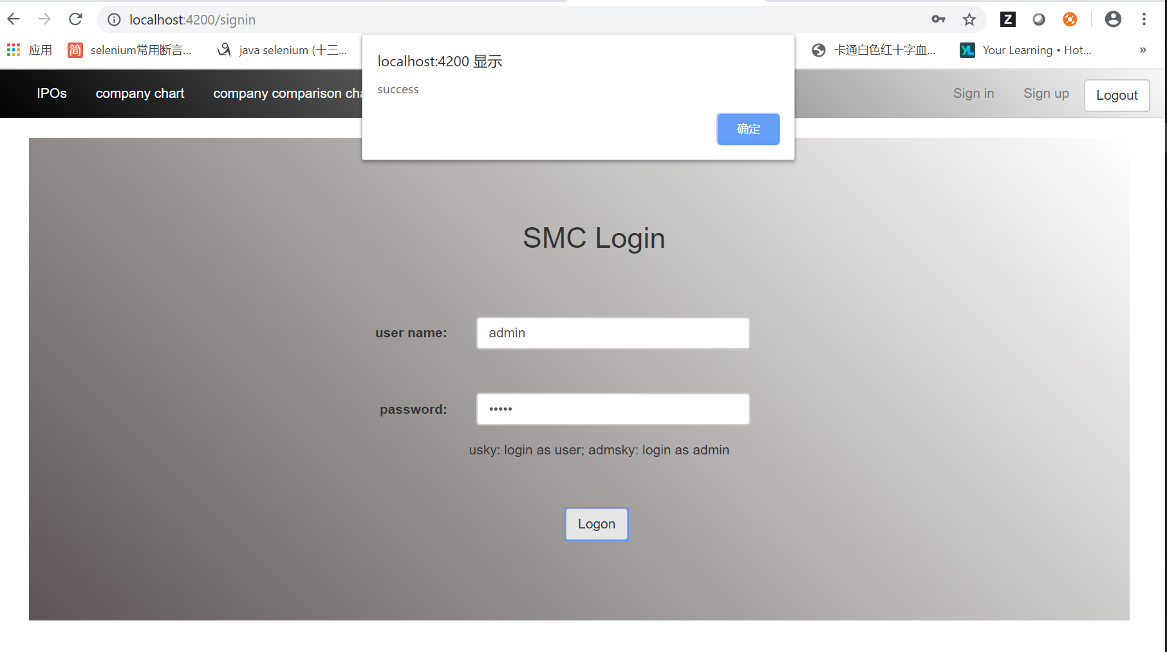

The admin user signin success, the welcome page is company list page.

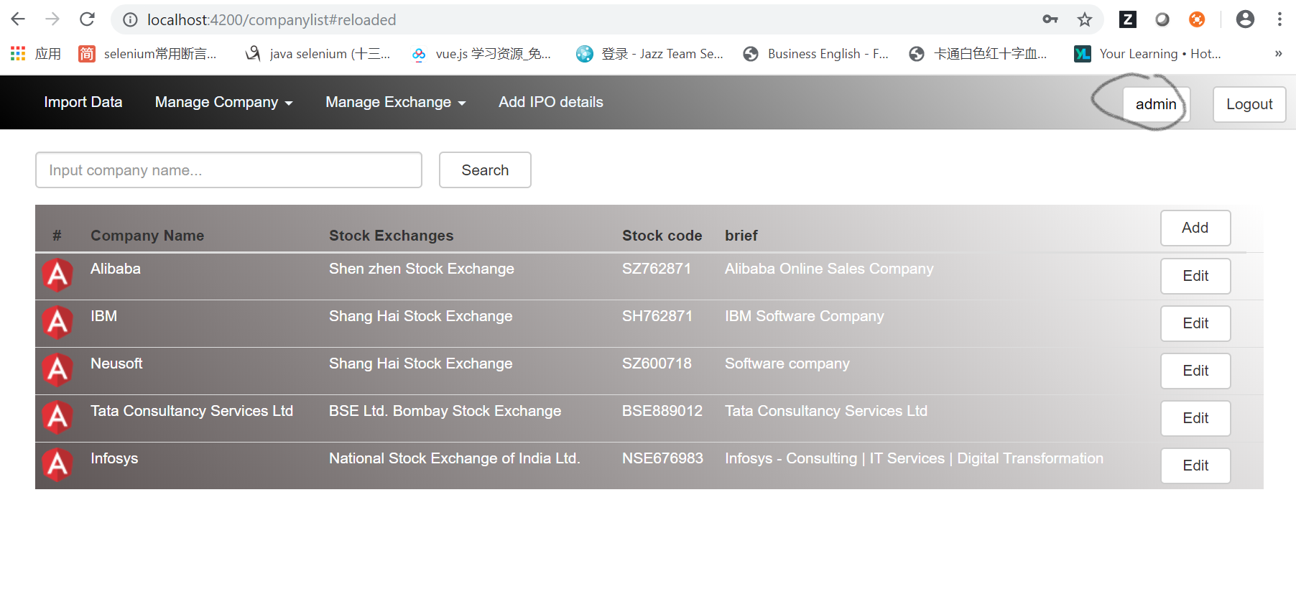

Admin user can search the company name.

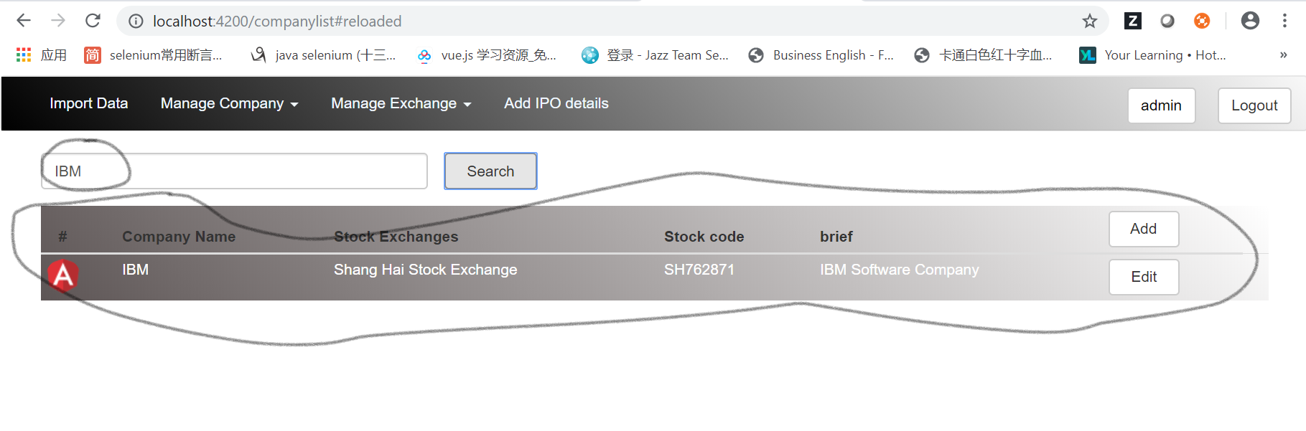

Admin user can add a new company.

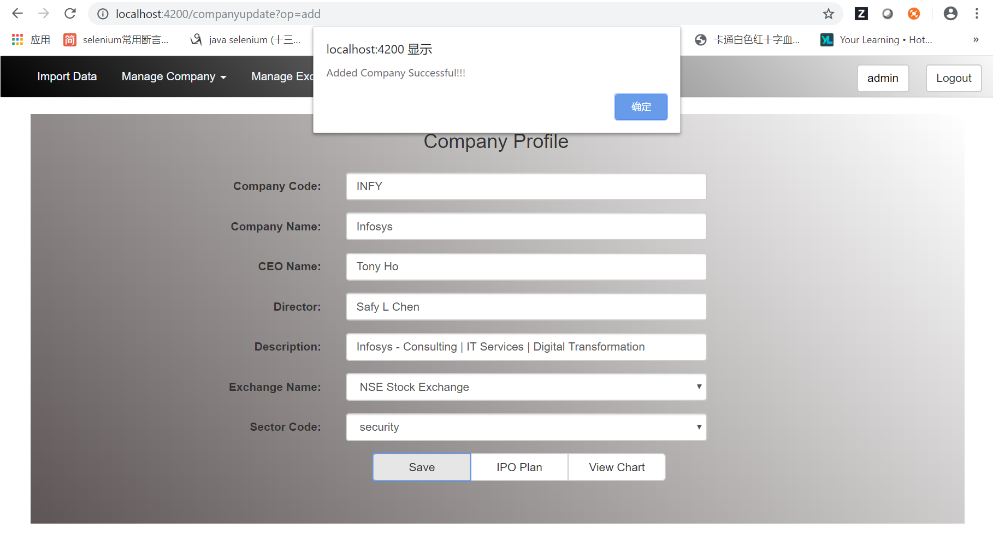

Admin user can add a new IPO record when after add a new company.

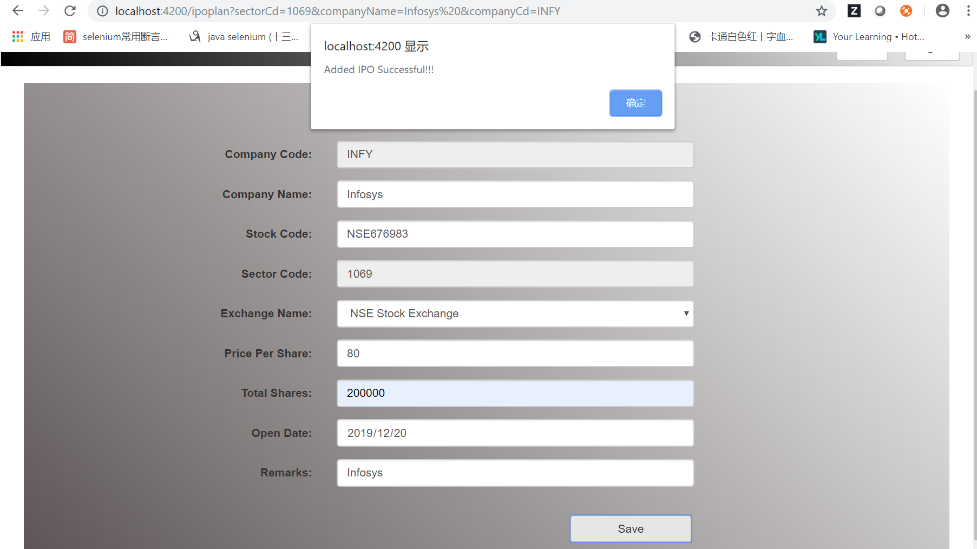

Admin user can click ‘Edit button’ in company list and edit the company information.

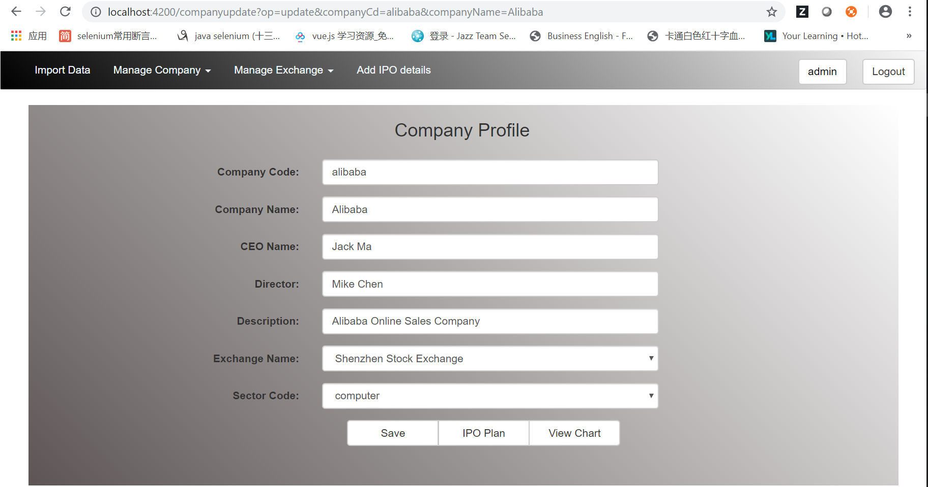

Admin user also can update this company’s IPO plan.

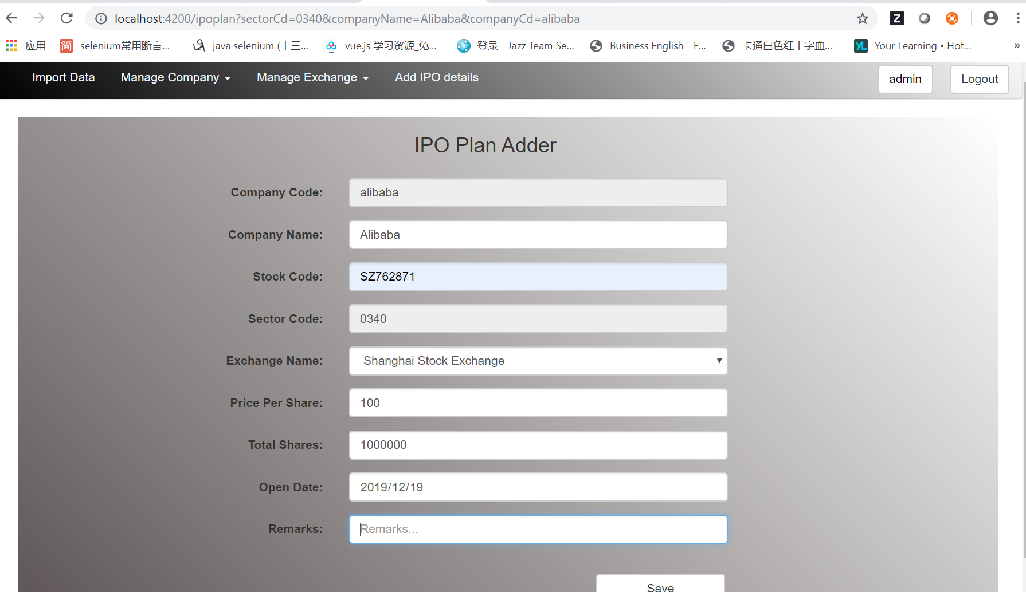

Admin user can import some stock value for new company or existing company.

And the import data can show out after finish upload.

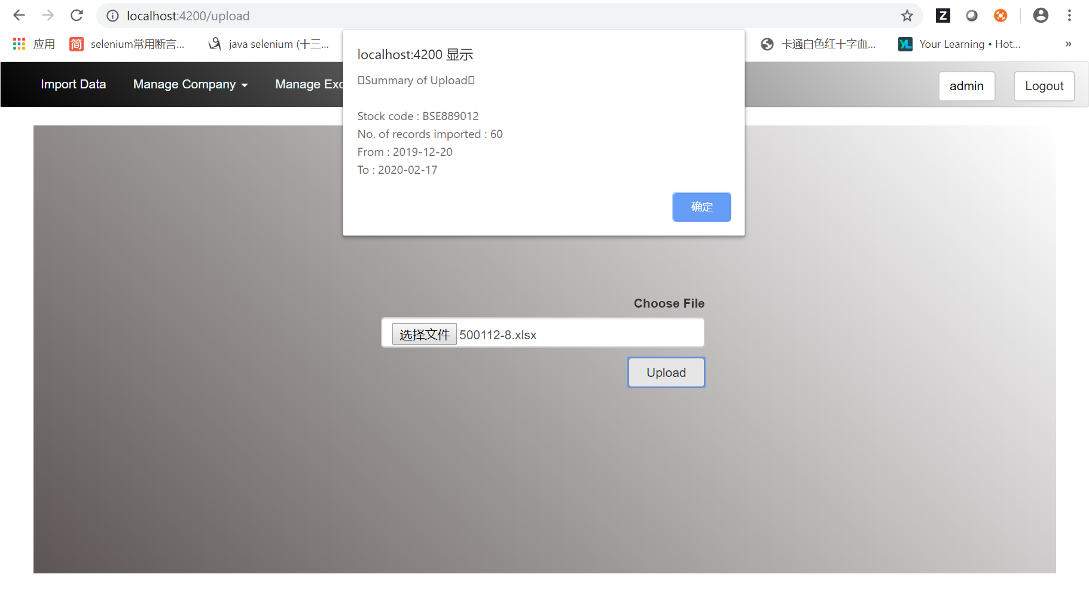

Admin user can find the exchange list.

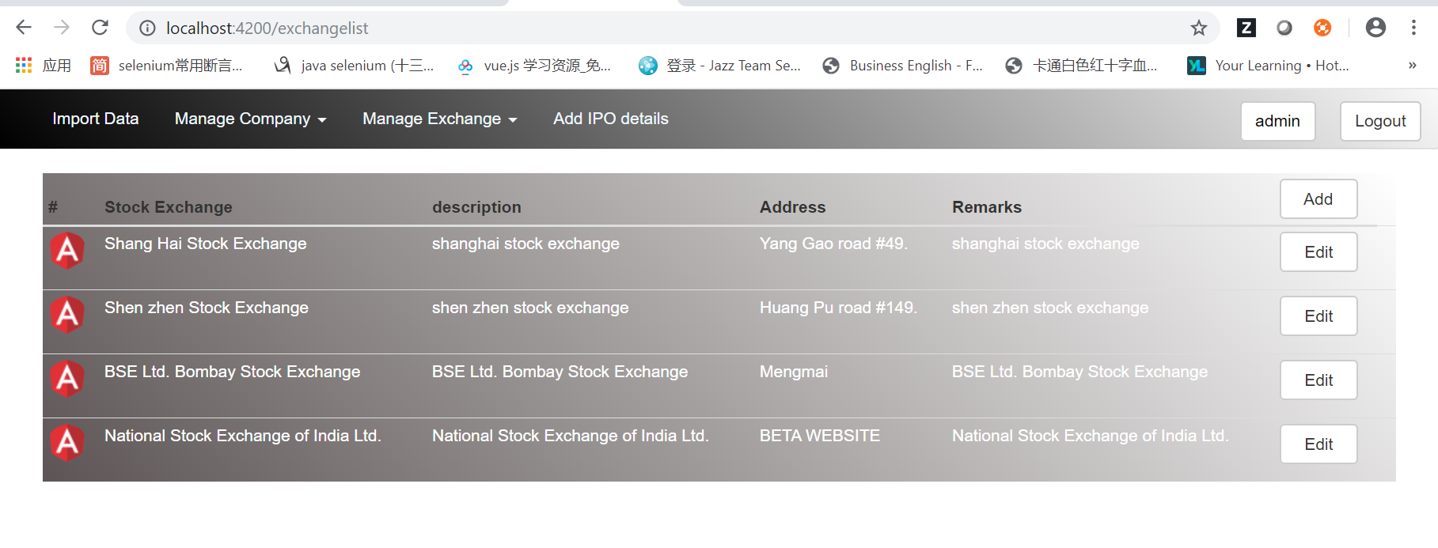

Admin user also can add a new exchange.

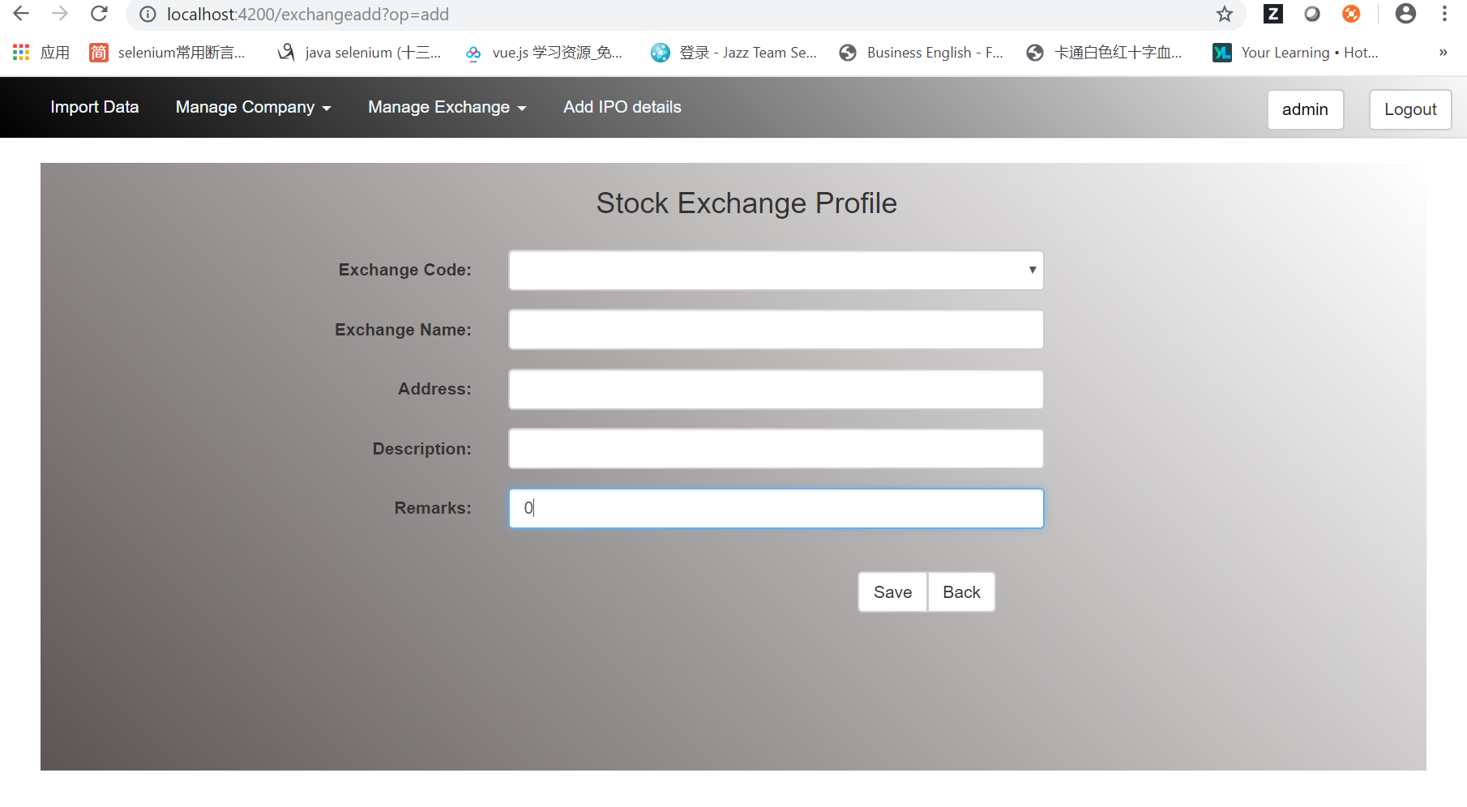

Admin user can add a new IPO

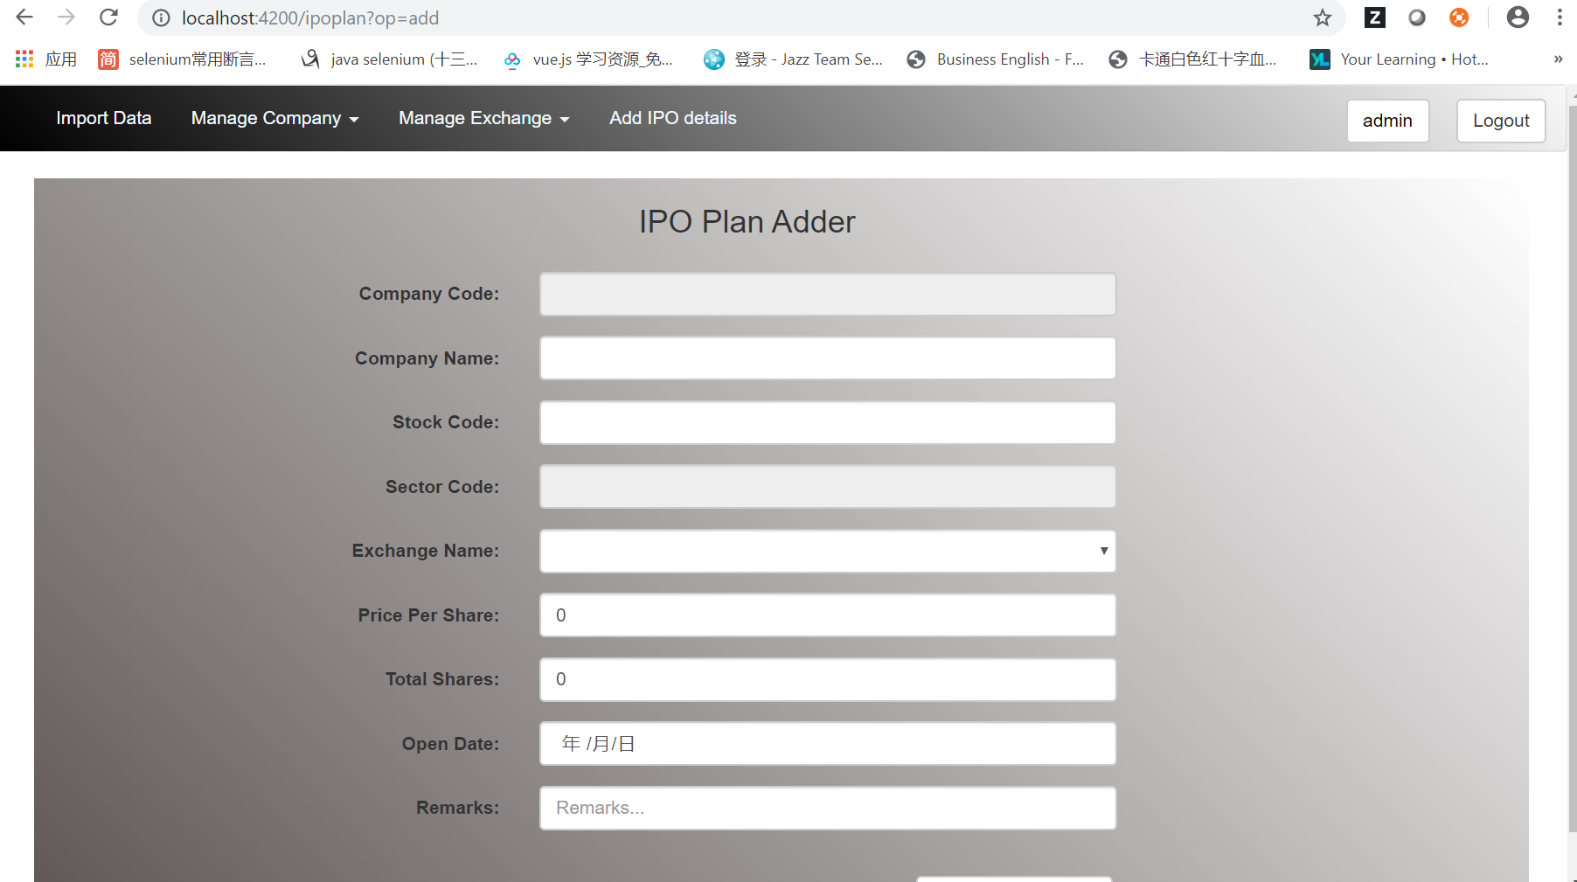

After admin user add all the information, we can switch to normal user.

This is show company chart for normal user ‘xinlhe’.

We can see the line chart and histogram chart.

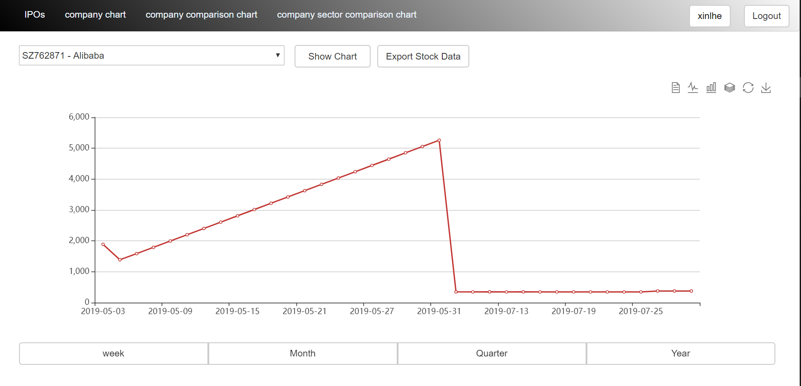

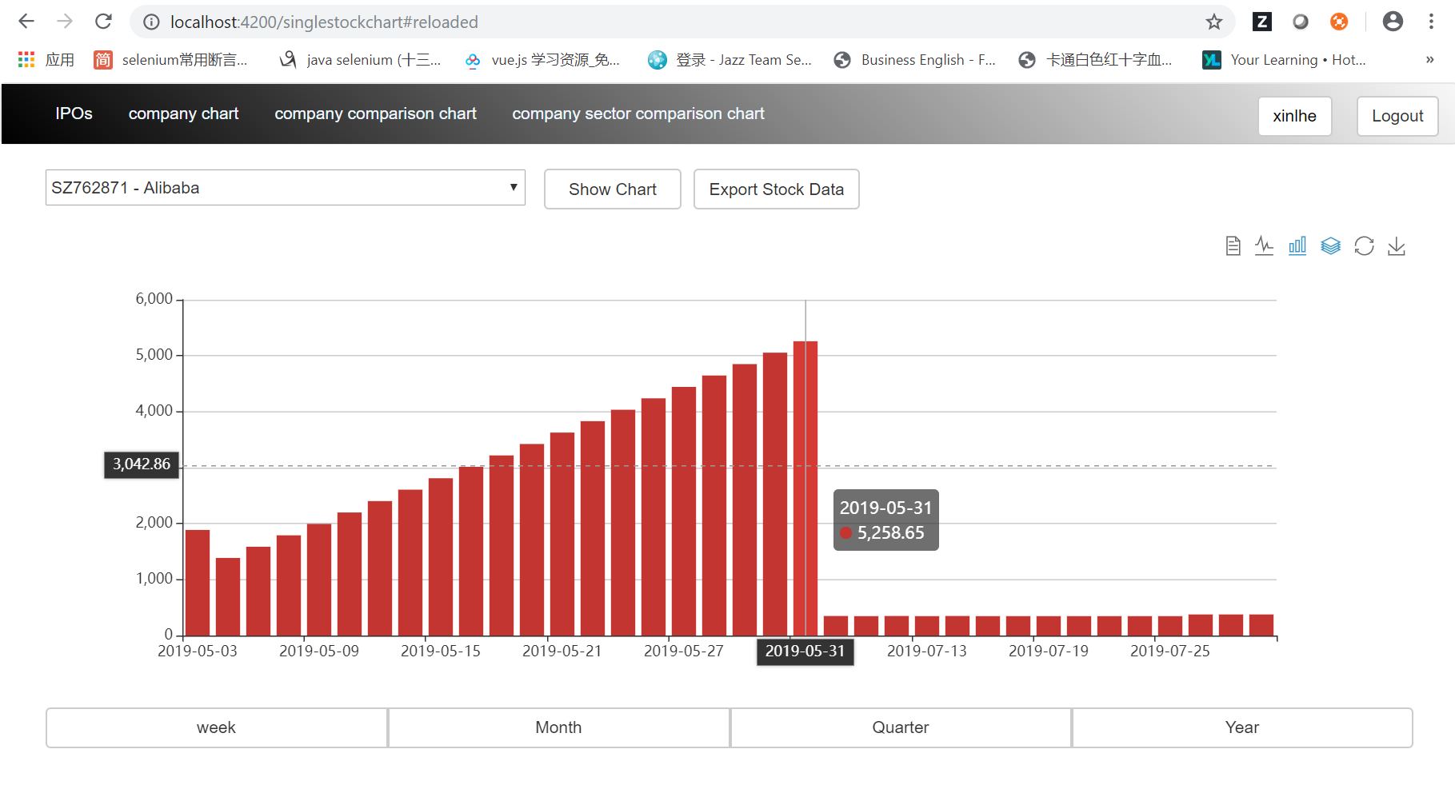

This page is show company comparison chart for normal user.

We can choose two company and choose two date to compare.

We can see these two companies line charts and histogram chart.

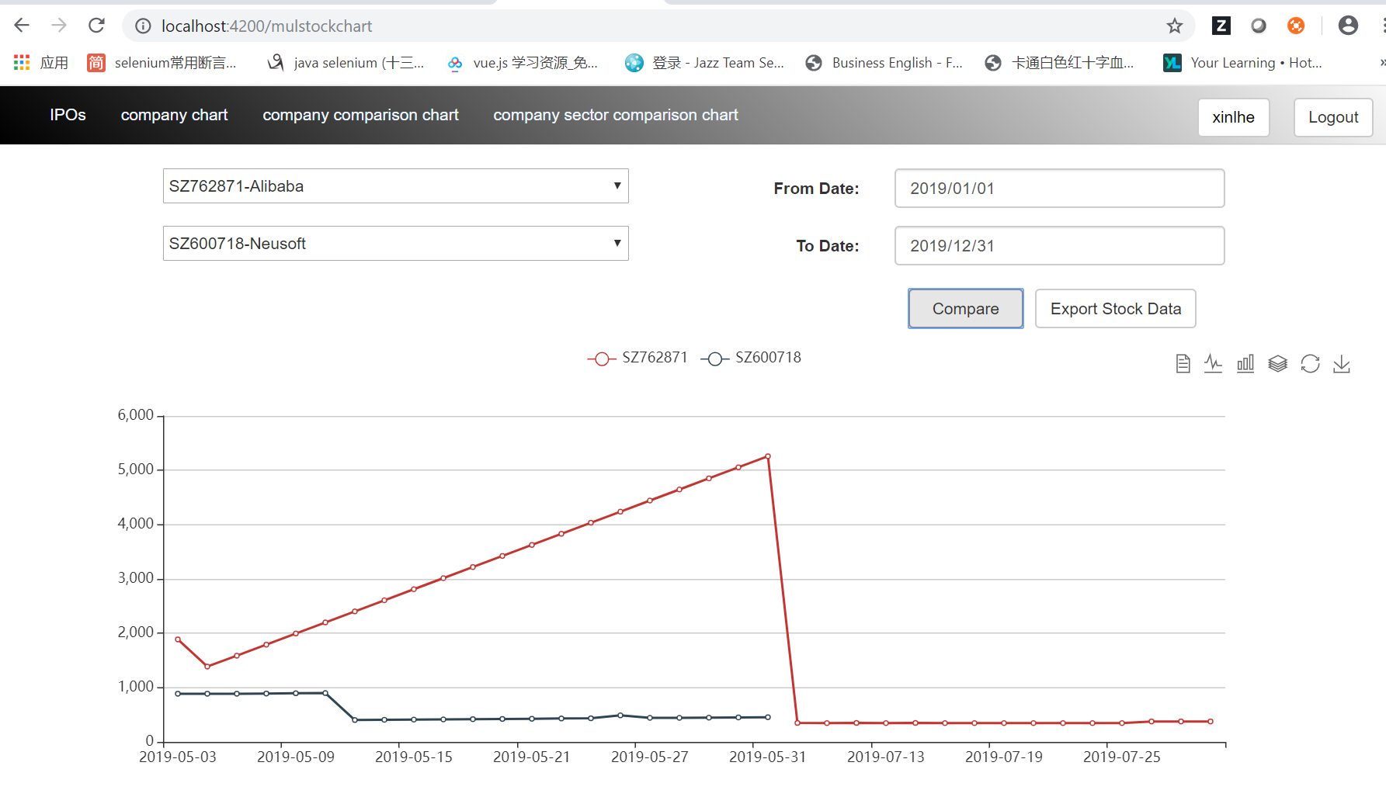

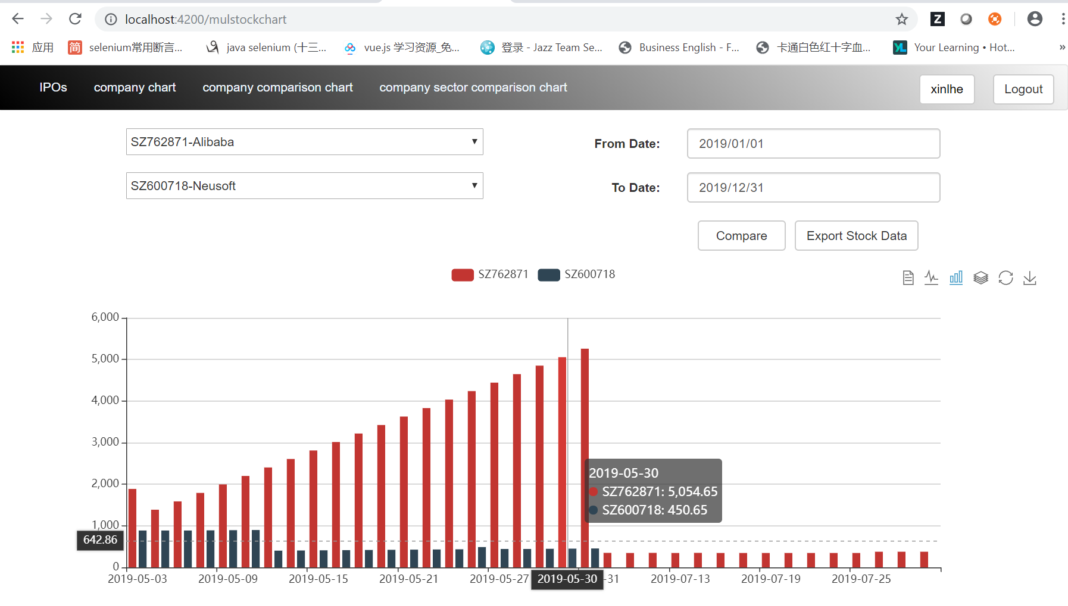

This page is show company sector comparison chart.

We can choose a company and choose two date. It will show this company and this company’s sector stock data and compare them.

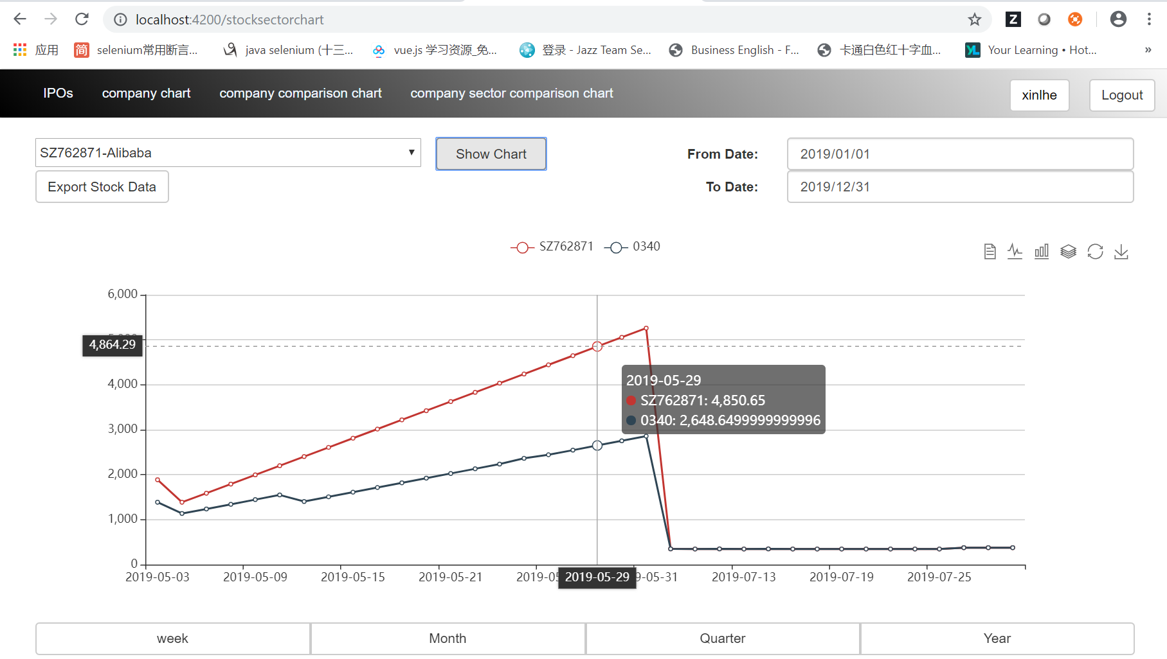

This page is SMC web services’ workspace in my local.

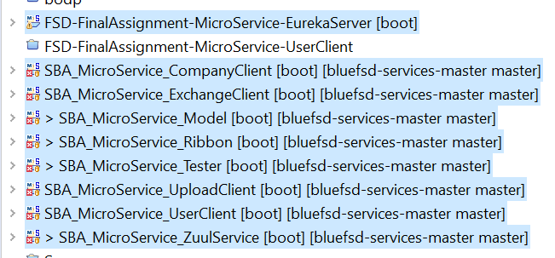

This page is SMC frontend workspace in my local.

